An artificial neural network (ANN) may be defined as an information-processing model that is inspired by the way biological nervous systems, such as the brain, process information. This model tries to replicate only the most basic functions of the brain. The key element of ANN is the novel structure of its information processing system. An ANN is composed of a large number of highly interconnected processing elements (neurons) working in unison to solve specific problems. Artificial neural networks, like people, learn by example. An ANN is configured for a specific application, such as pattern recognition or data classification through a learning process.

ADVANTAGES OF ANN

1. Adaptive learning: An ANN is endowed with the ability to learn how to do tasks based on the data given for training or initial experience.

2. Self-organization: An ANN can create its own organization or representation of the information it receives during learning time.

3. Real-time operation: ANN computations may be carried out in parallel. Special hardware devices are being designed and manufactured to take advantage of this capability of ANNs.

4. Fault tolerance via redundant information coding: Partial destruction of a neural network leads to the corresponding degradation of performance. However, some network capabilities may be retained even after major network damage

MULTIDISIPLINARY MODEL OF ANN

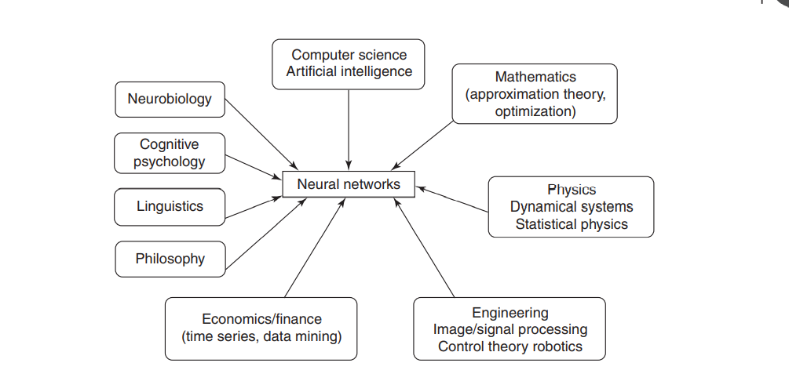

APPLICATIONS OF ANN

In medical diagnosis

Fraud detection

Air traffic control

Recognition of handwriting and typewriting

Predicting echo patterns

A comparison could be made between biological and artificial neurons on the basis of the following criteria:

1. Speed: The cycle time of execution in the ANN is of few nanoseconds whereas in the case of biological neuron it is of a few milliseconds. Hence, the artificial neuron modeled using a computer is more faster.

2. Processing: Basically, the biological neuron can perform massive parallel operations simultaneously. The artificial neuron can also perform several parallel operations simultaneously, but, in general, the artificial neuron network process is faster than that of the brain.

3. Size and complexity: The total number of neurons in the brain is about 1011 and the total number of interconnections is about 1015. Hence, it can be noted that the complexity of the brain is comparatively higher, i.e. the computational work takes places not only in the brain cell body, but also in axon, synapse, etc. On the other hand, the size and complexity of an ANN is based on the chosen application and the network designer. The size and complexity of a biological neuron is more than that of an artificial neuron.

4. Storage capacity (memory): The biological neuron stores the information in its interconnections or in synapse strength but in an artificial neuron it is stored in its contiguous memory locations. In an artificial neuron, the continuous loading of new information may sometimes overload the memory locations. As a result, some of the addresses containing older memory locations may be destroyed. But in case of the brain, new information can be added in the interconnections by adjusting the strength without destroying the older information. A disadvantage related to brain is that sometimes its memory may fail to recollect the stored information whereas in an artificial neuron, once the information is stored in its memory locations, it can be retrieved. Owing to these facts, the adaptability is more toward an artificial neuron.

5. Tolerance: The biological neuron possesses fault tolerant capability whereas the artificial neuron has no fault tolerance. The distributed nature of the biological neurons enables to store and retrieve information even when the interconnections in them get disconnected. Thus, biological neurons are fault tolerant. But in case of artificial neurons, the information gets corrupted if the network interconnections are disconnected. Biological neurons can accept redundancies, which is not possible in artificial neurons. Even when some cells die, the human nervous system appears to be performing with the same efficiency.

What is supervised learning and how is it different from unsupervised learning?

Supervised learning is a machine learning method in which models are trained using labeled data. In supervised learning, models need to find the mapping function to map the input variable (X) with the output variable (Y).

Supervised Machine learning

Supervised learning needs supervision to train the model, which is similar to as a student learns things in the presence of a teacher. Supervised learning can be used for two types of problems: **Classification** and **Regression**.

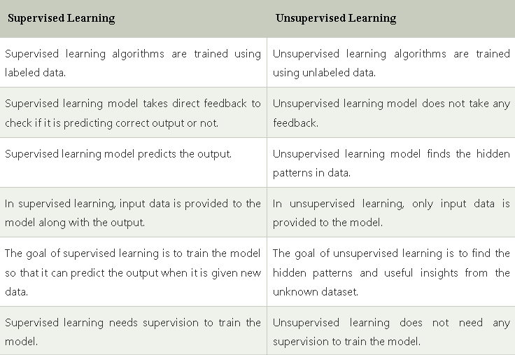

How does learning take place in supervised learning?

Supervised learning uses a training set to teach models to yield the desired output. This training dataset includes inputs and correct outputs, which allow the model to learn over time. The algorithm measures its accuracy through the loss function, adjusting until the error has been sufficiently minimized.

List the limitations of perceptron.

Output value of perceptron can take only one value

perceptron worked only with linearly separable classes.

Some scientists even went on to discover and state that a perceptron didn’t even have the ability to learn a simple logical function like ‘XOR’.

Applications of perceptron

**Data Compression, Streaming Encoding**. Data Encryption - Data Security. Data Visualization. Autonomous Driving.

With a neat flowchart, explain the training process of perceptron network

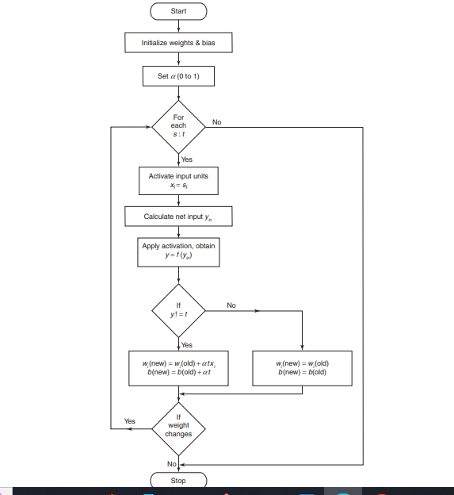

Applications of adaline

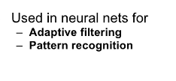

Applications of madaline

